Task 1: Launched and opened THM room

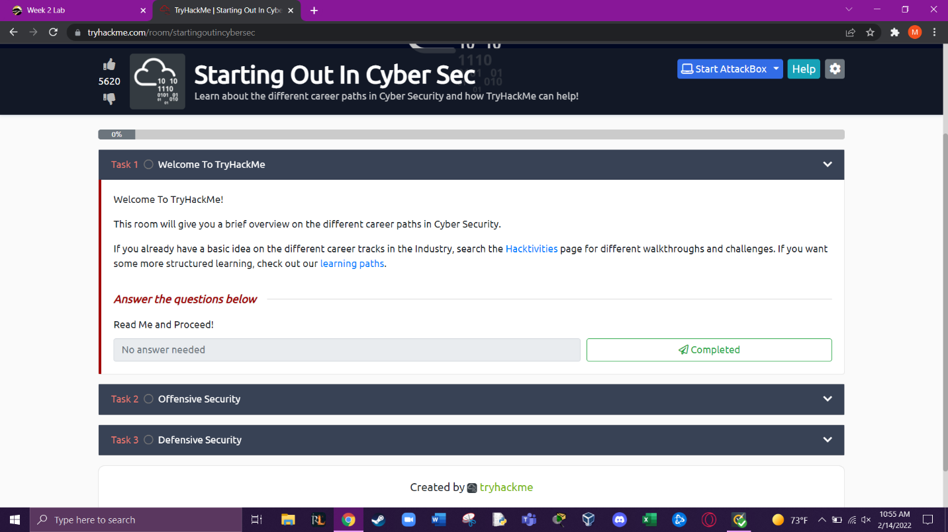

Task 2: A penetration tester or pen tester for short is someone employed to find vulnerabilities in an application.

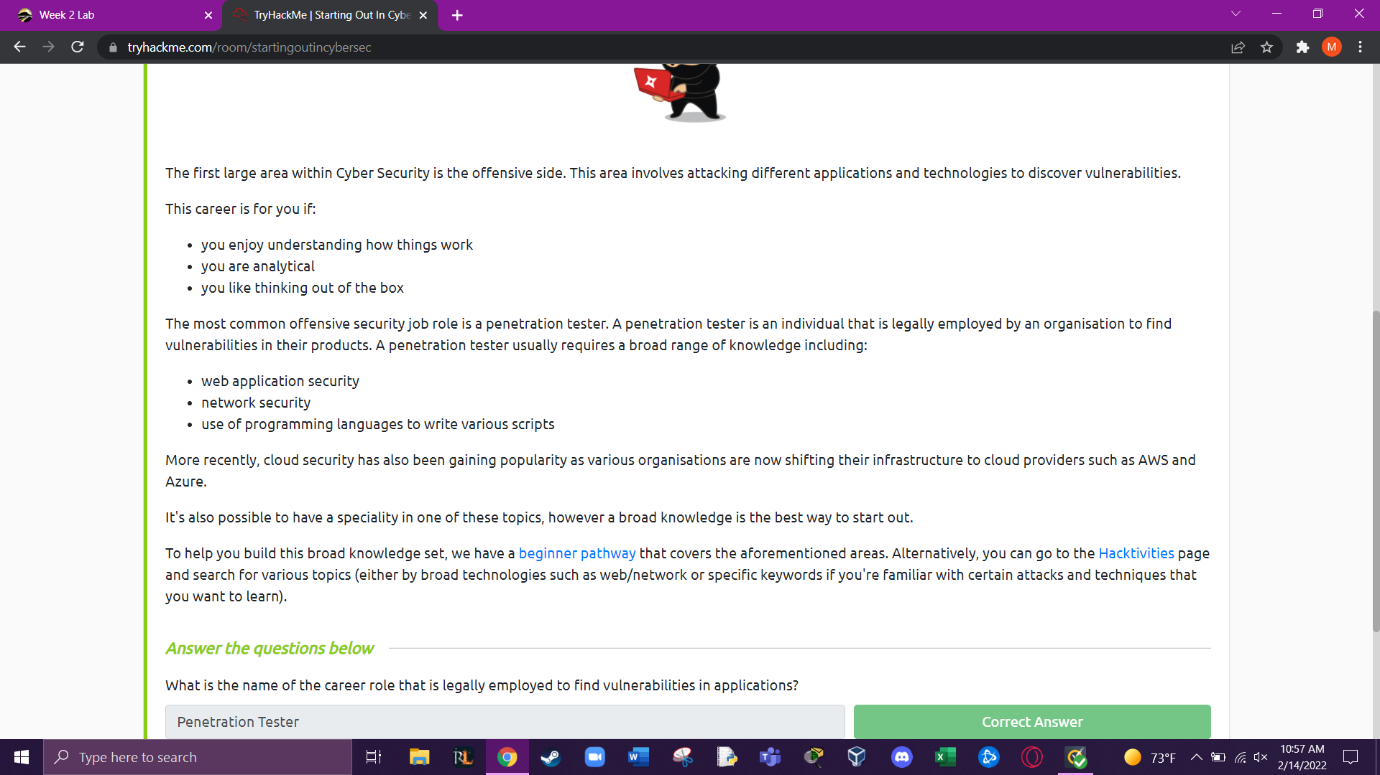

Task 3: A security analyst is a person whose job is to identify attacks against an organization.

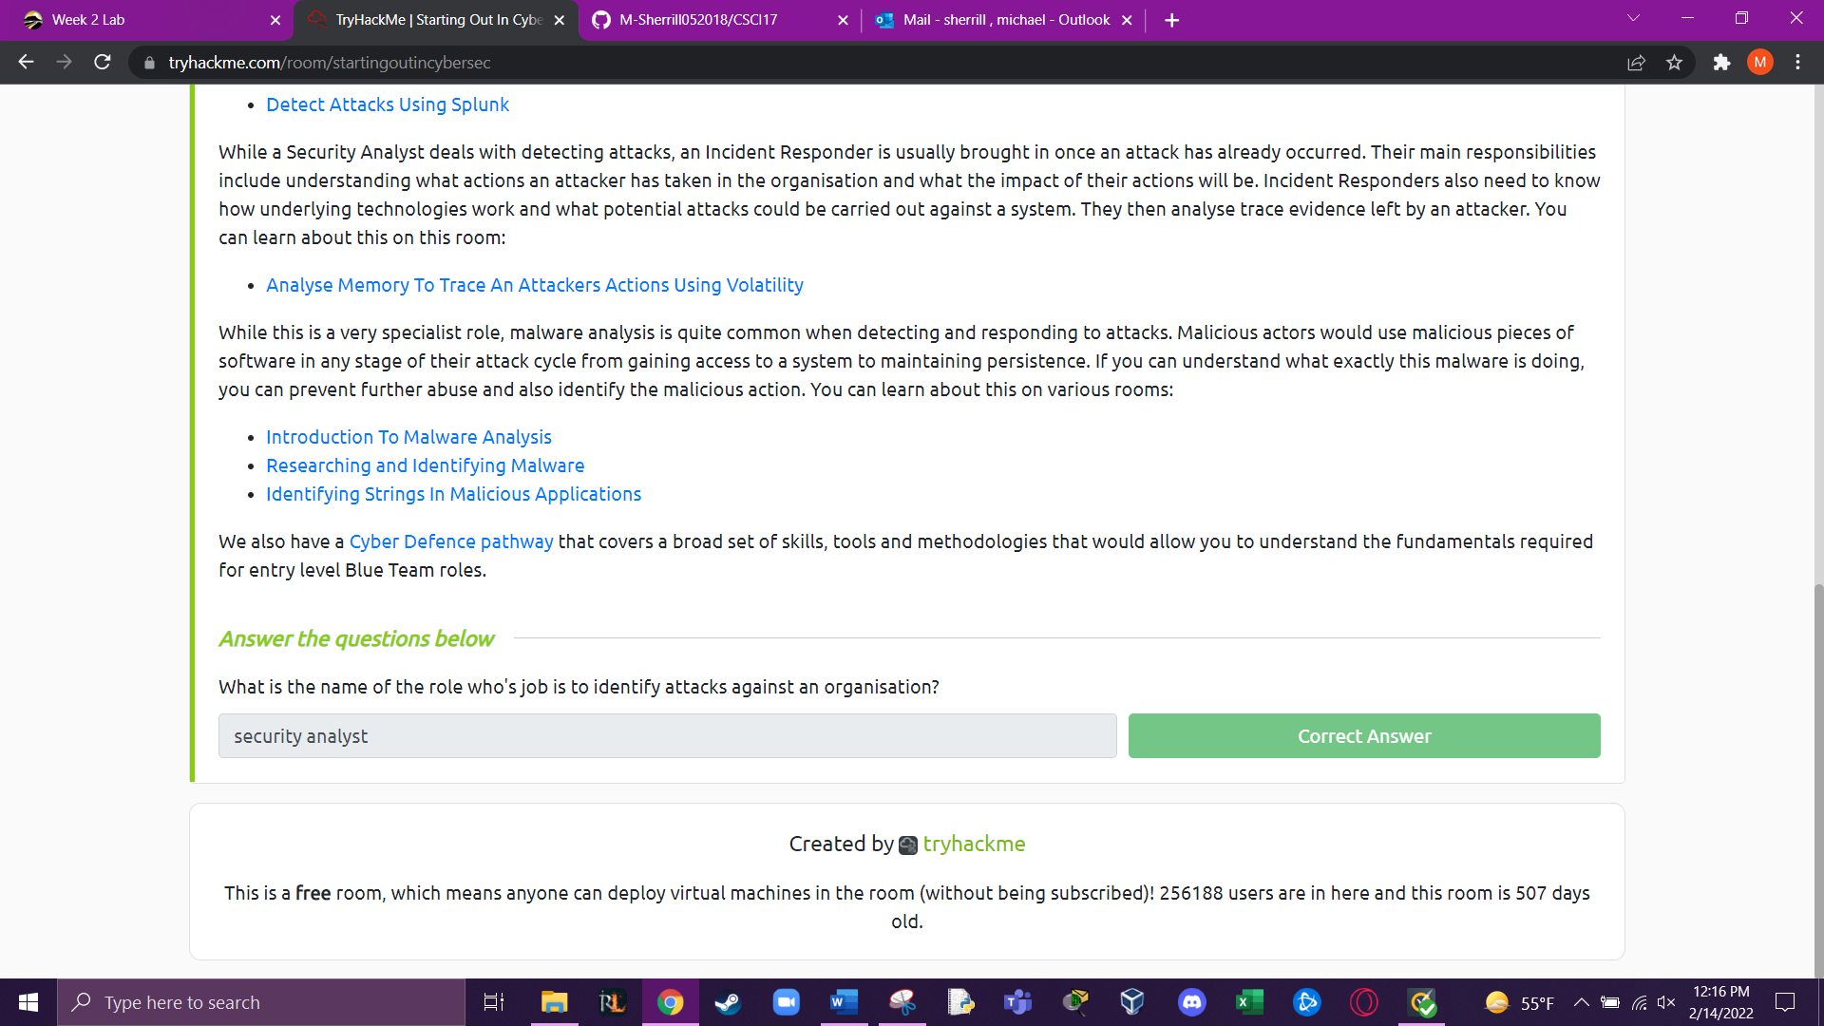

Completed Room:

